Thadomal Shahani Engineering College, Bandra
Department of Artificial Intelligence & Data Science
Experiment 06
Date of Performance: 13/09/2026 Date of Submission: 13/09/2026 Class: T1
Student Roll No: 34,41,43,44
Student Name:Ishita Gurbaxani, Lakshya Kanjwani, Yuvraj Keswani , Bhavisha kewalramani
LO Mapped: Build and manage automated CI/CD pipelines for application development, testing, packaging, and deployment.
Aim: To study and Implement Agile Software Project lifecycle using Jira with DevOps Pipeline Integration.

Jira Agile Project Management User Manual
Source Video | Ultimate Jira Tutorial for  Beginners | Instructor | Stewart Gauld
Project  Example | Sheify Website  Development (key: SWD) | Video URL | youtube.com/watch?v=8jW  KwiIcWPI
Tools Used | Jira (Scrum), GitHub | Sprint | SWD Sprint 1 (3 Jun – 1  Jul)
- Account Creation & Initial Setup [00:00 - 02:00]
    - Navigate to Jira: Visit Jira's official portal and select 'Get Jira for free'.
    - Tier Limits: Jira Free tier supports up to 10 users, suitable for standard Scrum teams (typically 5 to 9 members).
    - Account Registration: Enter work email, verify with the security code, input full name, create password, and enter business/organization domain.
    - Work Type Selection: Select 'Software Development' and choose the 'Scrum' methodology.
- Project Creation & Team Member Invitations [02:00 - 03:30]
    - Project Name: Set the project name as 'Sheify Website Development' (project key: SWD).

    - Invite Collaborators: Navigate to the team icon in the top navigation bar, input collaborator email addresses, configure invite permissions, and click 'Add people'.
- Work Breakdown Structure & Epic Management [03:40 - 06:40]
The Scrum framework is organized hierarchically into four core layers:
    - Roadmap: Top-level strategic project goals.
    - Epics: Large initiatives broken into deliverables (managed by Product Owner).
    - User Stories: Functional requirement units that deliver customer value.
    - Tasks / Sub-tasks: Specific technical tasks completed by developers.
Configured Project Epics
    - Epic 1: SWD-1 ‘Improve Customer Service’.
    - Epic 2: SWD-2 ‘Increase Product Page Conversions’.
The List view shows both epics with their assignee, reporter, priority and status. Both start in the To Do status.
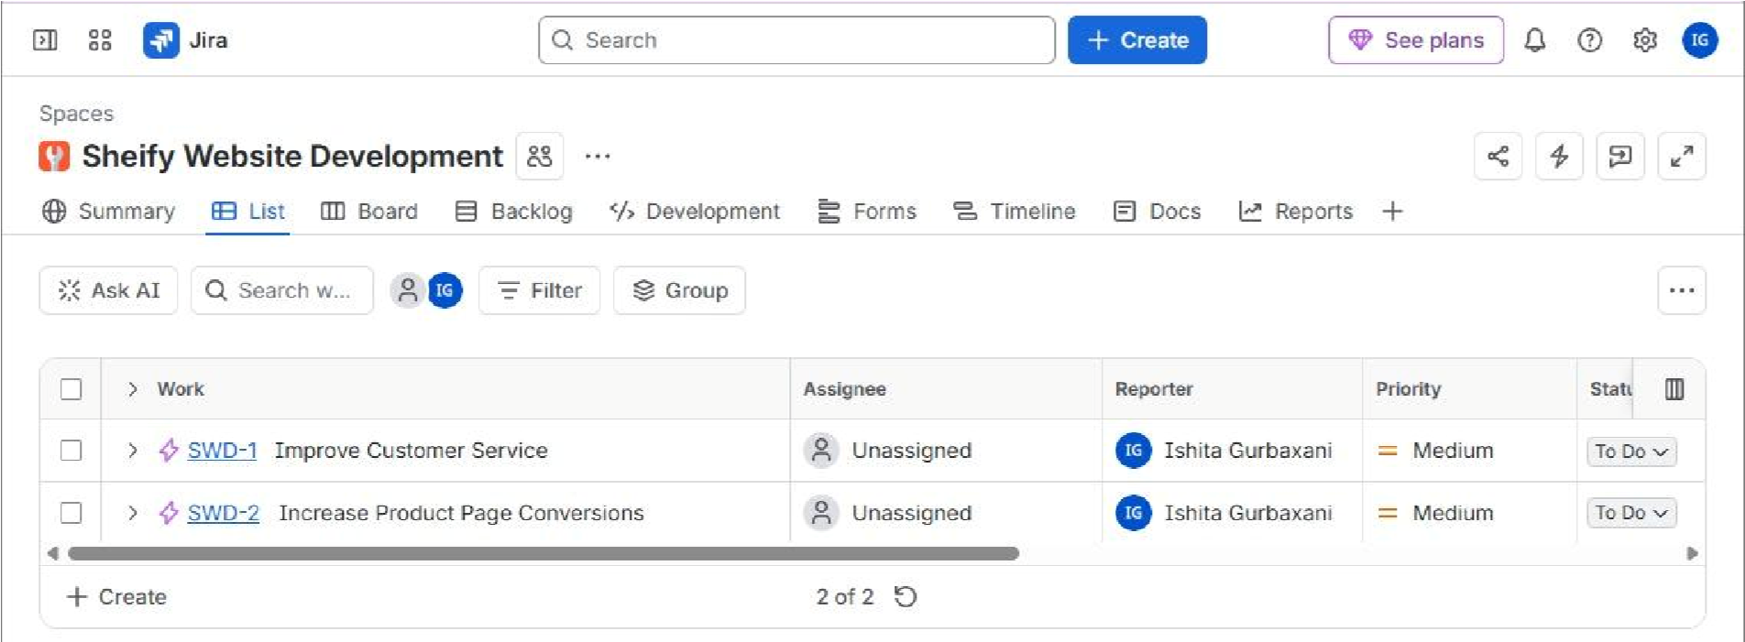
- Backlog Refinement, Stories & Tasks [06:40 - 09:30]
In the Backlog view, the team creates work items and assigns each one to a parent epic. Items planned for the first iteration sit in the sprint section; the remaining items stay in the Backlog section below it.
Issue Key | Type | Summary / Requirement | Parent Epic
SWD-1 | Epic | Improve Customer Service | —
SWD-2 | Epic | Increase Product Page Conversions | —
SWD-4 | Task | Provide live chat as a feature | SWD-1 Improve  Customer Service
SWD-5 | Task | Add WhatsApp chat to our website | SWD-1 Improve  Customer Service
SWD-6 | Task | Add Facebook messenger chat to our website | SWD-1 Improve  Customer Service
SWD-7 | Story | Create a video based knowledge base | SWD-1 Improve  Customer Service
SWD-8 | Story | Create a review based system for  collecting reviews | SWD-2 Increase  Product Page  Conversions

Issue Linking & Dependencies
To deliver SWD-4 (‘Provide live chat as a feature’), developers must first complete two blocker tasks. SWD-4 is linked to SWD-5 and SWD-6 with the relationship ‘is blocked by’ (see the Linked work items panel below).
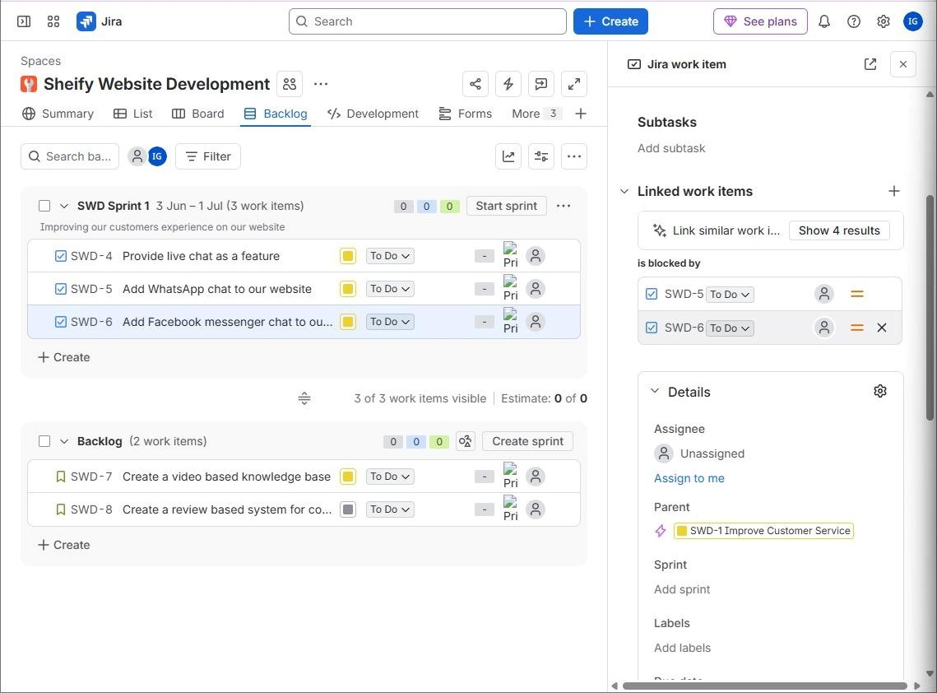
- Sprint Planning & Starting the Sprint [09:55 - 12:50]
    - Set Sprint Parameters: Open the sprint and click 'Start sprint'. Enter the sprint name (SWD Sprint 1), choose a custom duration, and set the start date (3 June) and end date (1 July).
    - Sprint Goal: Improving our customers experience on our website.
    - Move Items into Sprint: Drag SWD-4, SWD-5 and SWD-6 from the Backlog into SWD Sprint 1 (3 work items).
    - Click Start: Click ‘Start’ in the dialog. Jira transitions the sprint into the live Active Board and confirms with a ‘Sprint started’ message.
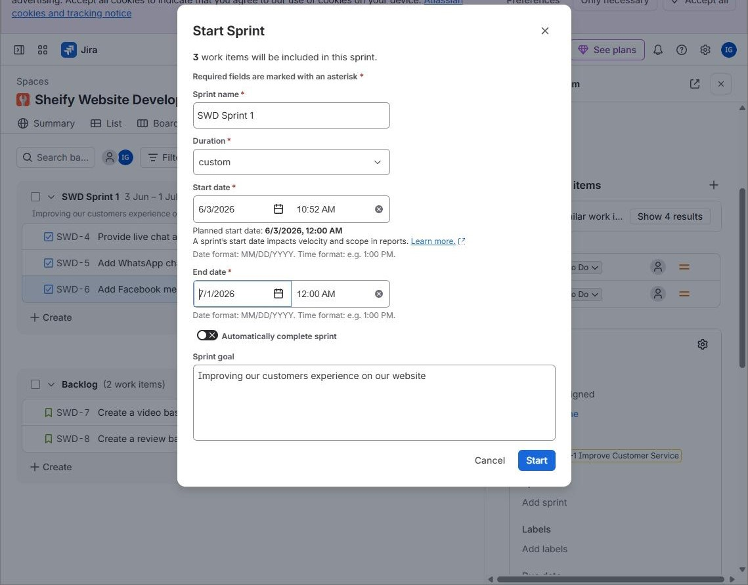
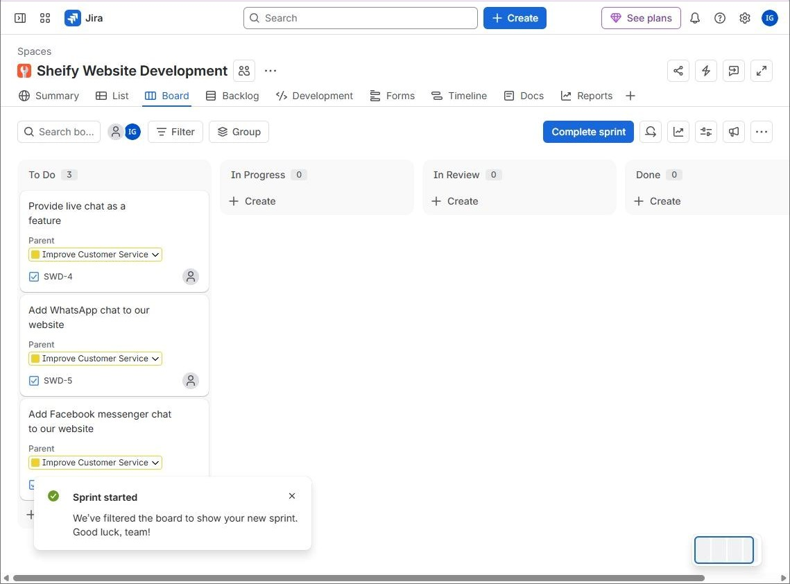
- Sprint Execution & Status Progression
As developers pick up work, they drag cards across the board columns: To Do → In Progress → In Review → Done. In this project, SWD-4 moved to In Progress, SWD-5 moved to In Review, and SWD-6 remained in To Do.
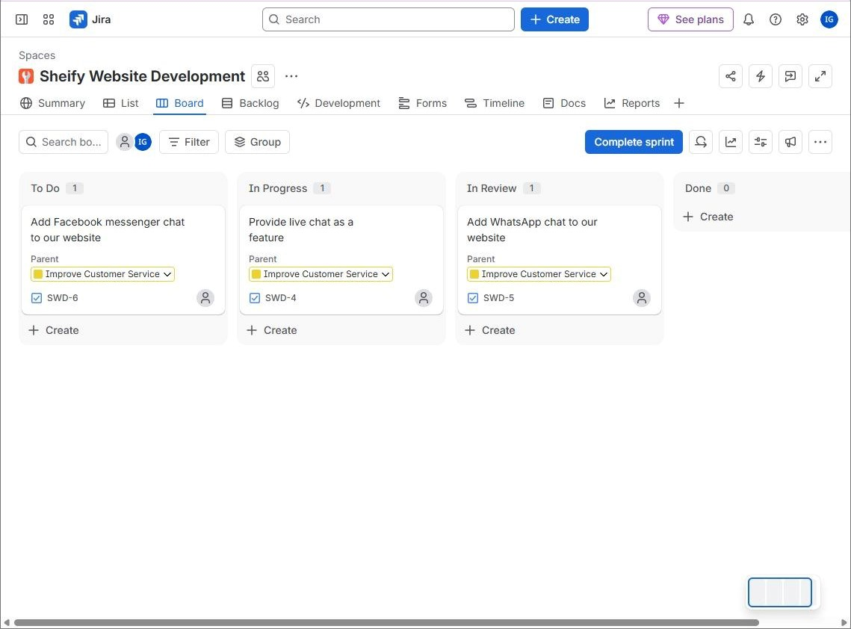
- Timeline View [11:34 - 13:00]
The Timeline (Gantt-style) view visualizes epics, their child work items, and the sprint across the months. The sprint appears as a bar above the epics, and each epic shows a progress bar of its child items by status.
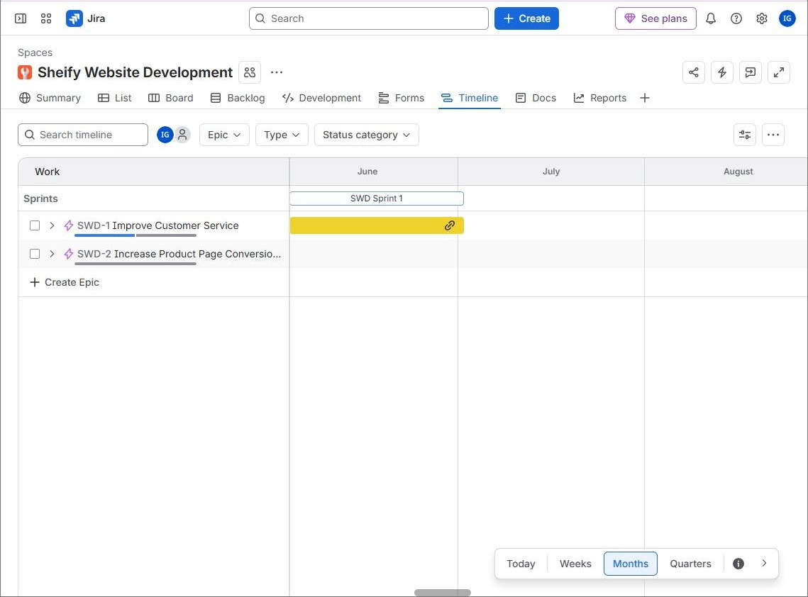
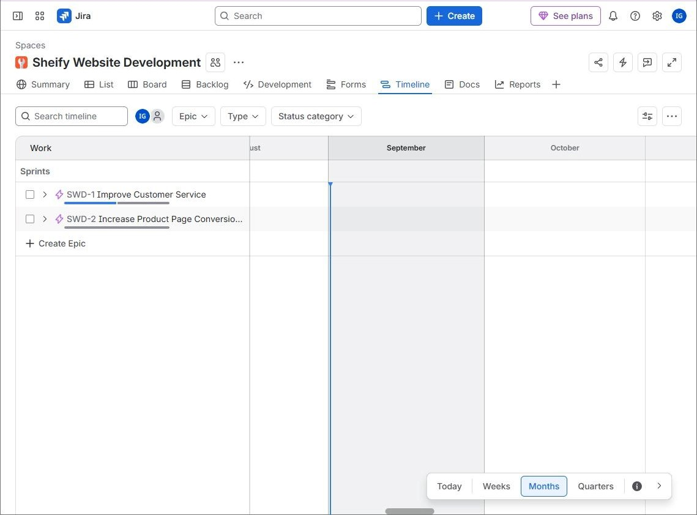
- GitHub Integration & Development Panel
Jira can be connected to GitHub so that code activity appears on the work item. The key step is to include the Jira issue key (for example SWD-5) in the commit message.
    - Create the change: In the GitHub repository (Sheify-Website-Development), edit or add a file on the main branch and click ‘Commit changes’.
    - Name the commit with the issue key: Enter a commit message that starts with the key,
e.g. ‘SWD-5: added WhatsApp chat integration’, then confirm the commit.
    - Check the repository: The new commit appears at the top of the file list with its short hash.
    - Check Jira: Open the work item’s Development panel and select the Commits tab. The commits are listed automatically.
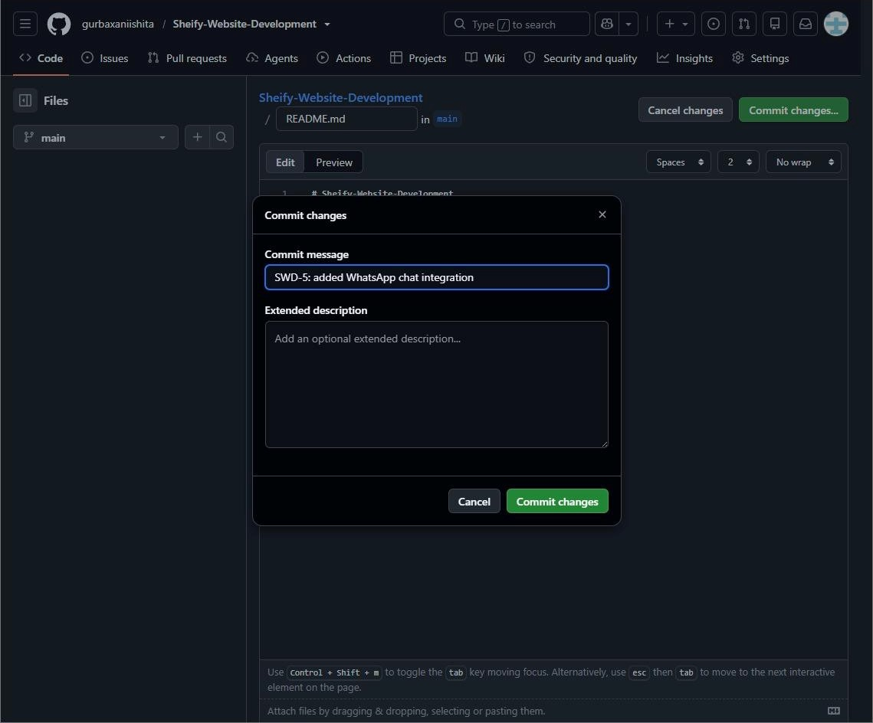

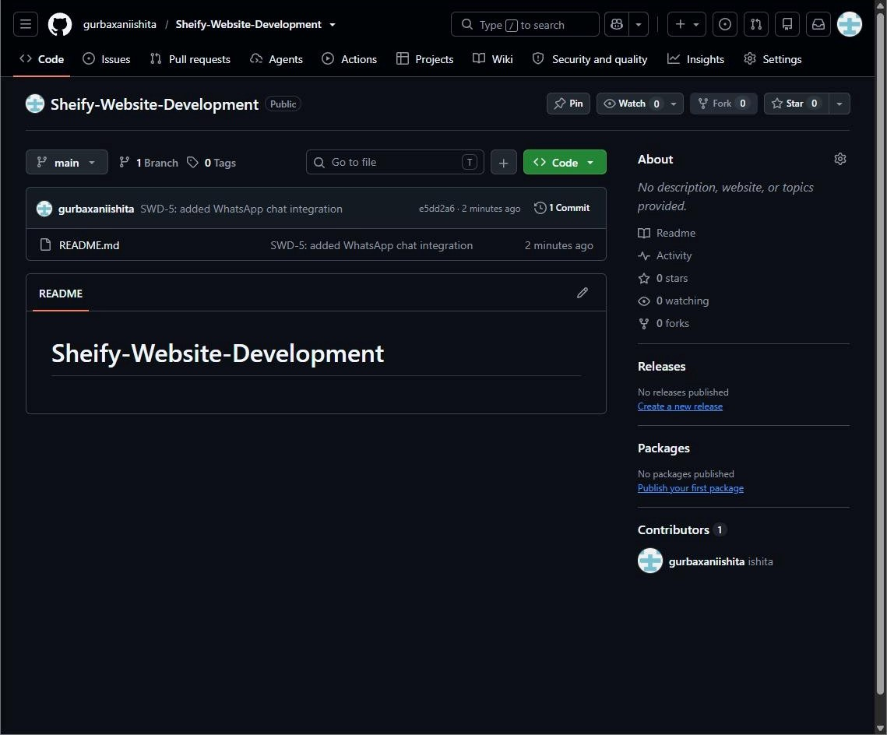
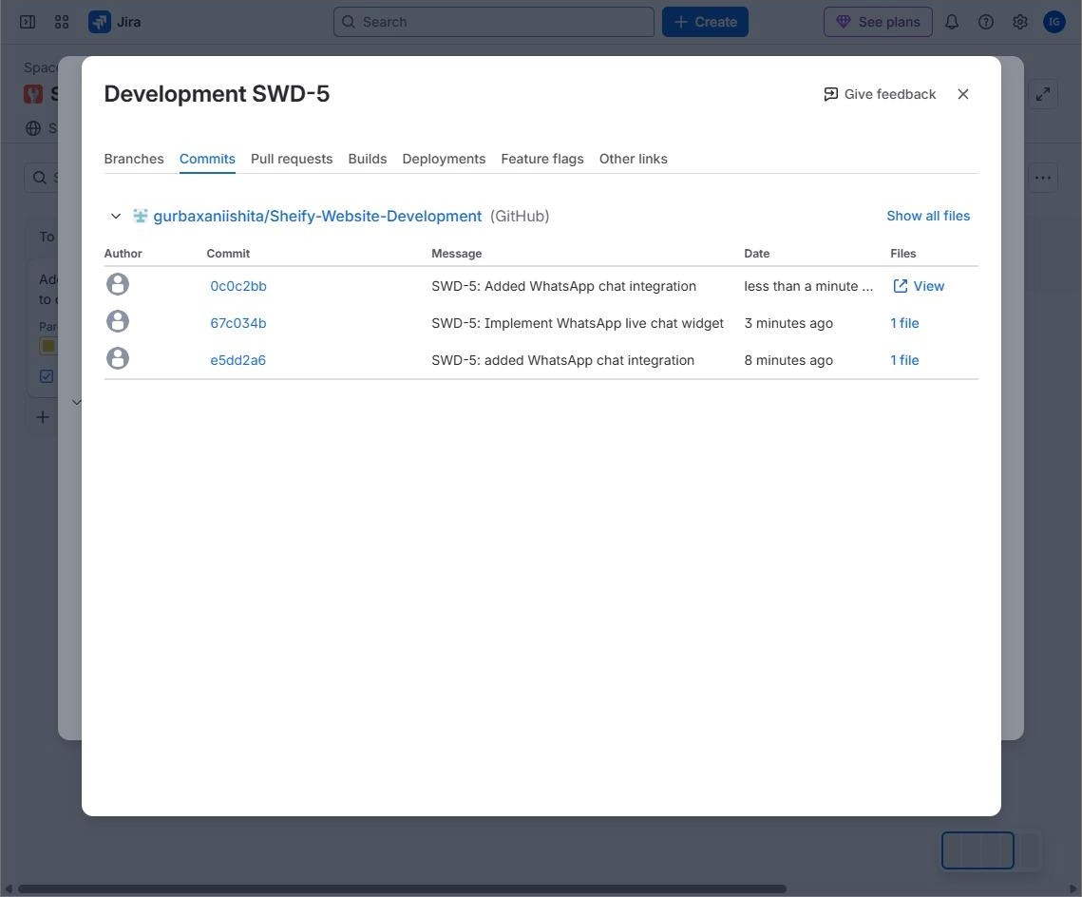
- Dashboards & Gadgets [13:30 - 15:00]
Dashboards give the team an at-a-glance summary using gadgets. The SWD Sprint 1 dashboard includes an Activity Stream (a live log of status changes, sprint updates, parent changes and issue links), a Sprint Burndown Gadget, a Sprint Health Gadget, a Pie Chart by assignee, and an Assigned to Me gadget.
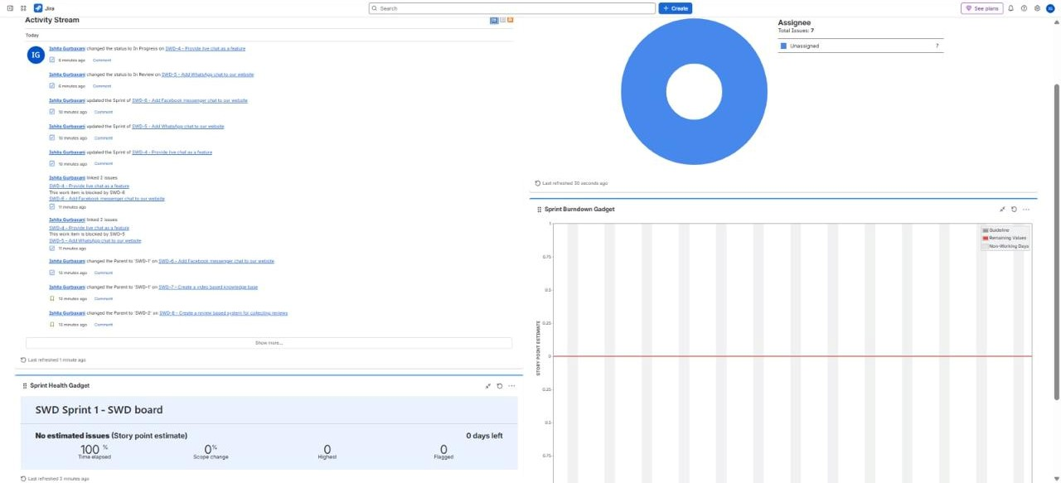
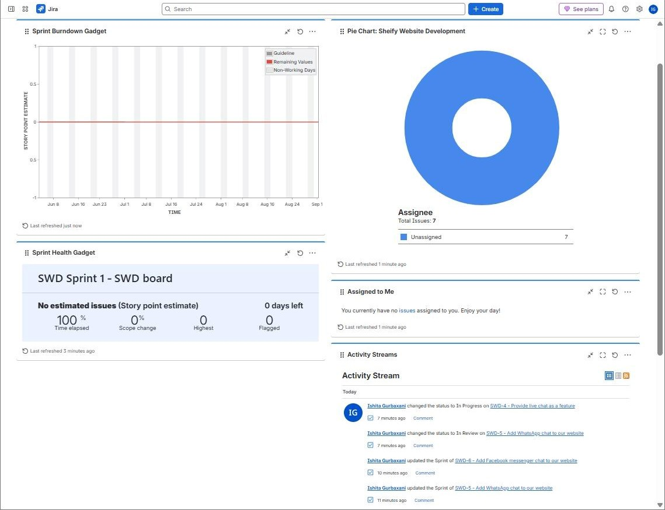
Reading the gadgets
The burndown and sprint health gadgets show no values because the work items have no story point estimates. Add estimates to the items to get a meaningful burndown line.
- Reports [15:00 - 15:30]
The Reports tab summarizes project data: work items by status, type and assignee, plus the work item creation trend and cycle time. In this project the project has 7 work items (Tasks, Stories and Epics), all unassigned.
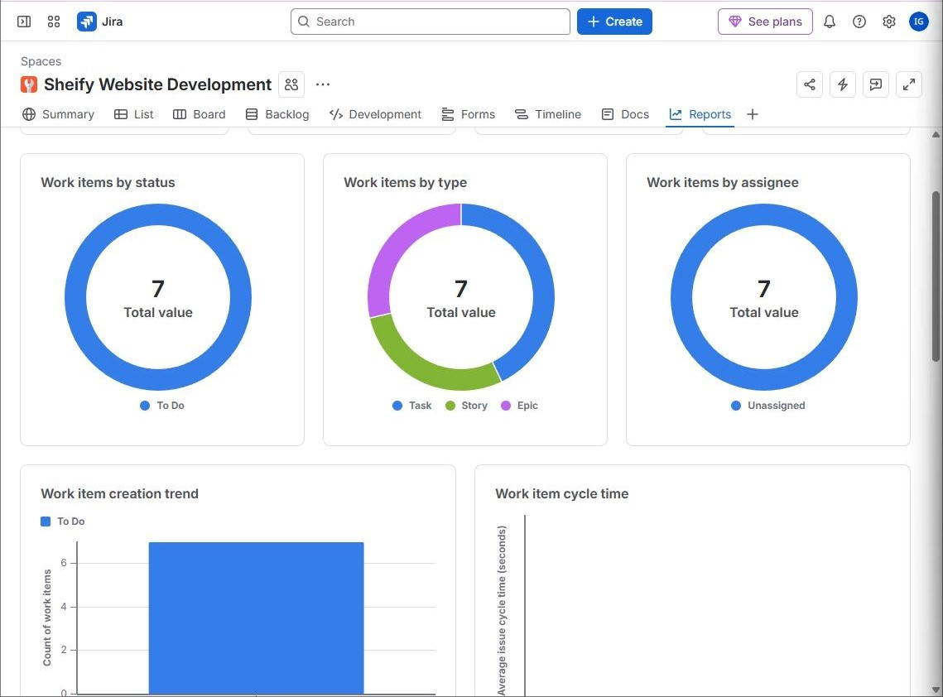
- Other Integrations
    - Project Pages & Retrospectives: Integrated Confluence spaces for team sprint retrospectives.
    - App Integrations: Third-party apps such as Slack, Google Forms and TimeCamp (time tracking) can be connected to Jira.

